CSS Documentation – Portfolio Website Styling
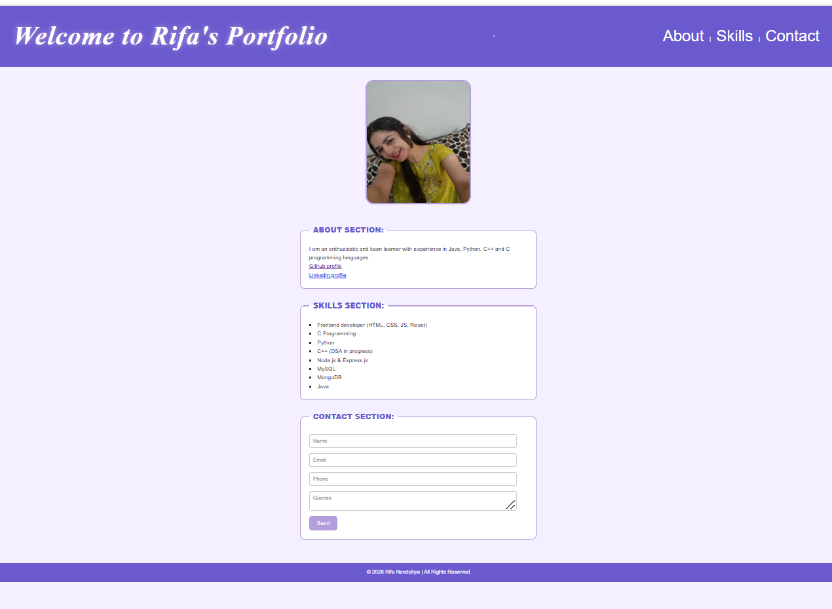
1. Project Overview
This CSS file is designed to create a modern, elegant, and visually appealing portfolio website using a lavender-themed colour palette, smooth animations, and a responsive layout. The goal is to enhance user experience through clean design, readable typography, interactive elements, and adaptability across different screen sizes.

2. CSS Concepts Used
a. CSS Reset
* {
margin: 0;
padding: 0;
box-sizing: border-box;
}
This removes browser default spacing and ensures consistent sizing using box-sizing: border-box.

b. CSS Variables (Custom Properties)
:root {
--primary-color: #b39ddb;
--secondary-color: #6a5acd;
--accent-color: #9575cd;
--bg-color: #f5f0ff;
--text-color: #2e2e3a;
}
Used for:
- Easy theme customization
- Consistent colors throughout the site
- Better maintainability

c. External Fonts
@import url('https://fonts.googleapis.com/css2?family=Playfair+Display...&family=Poppins...');
- Playfair Display → Used for main headings (elegant, serif style)
- Poppins → Used for body text (clean and modern)

d. Flexbox Layout
Used for alignment and layout:
#head_id, #main_id, #aside_id {
display: flex;
}
Benefits:
- Easy centering of elements
- Flexible and responsive layout
- Clean alignment of header, navigation, image, and content

e. Animations & Transitions
Transitions
transition: transform 0.5s ease, box-shadow 0.5s ease;
Applied to:
- Buttons
- Images
- Fieldsets
- Navigation links
This gives smooth hover effects.
Keyframe Animations
@keyframes slideDown { ... }
@keyframes fadeIn { ... }
@keyframes glow { ... }
Used for:
- Header entrance animation
- Footer fade-in
- Glowing main heading effect

f. Hover Effects
#nav_id a:hover { transform: scale(1.1); }
button:hover { transform: translateY(-3px) scale(1.05); }
#aside_id img:hover { transform: scale(1.08) rotate(2deg); }
Purpose:
- Adds interactivity
- Makes UI feel dynamic and engaging

3. Design Decisions
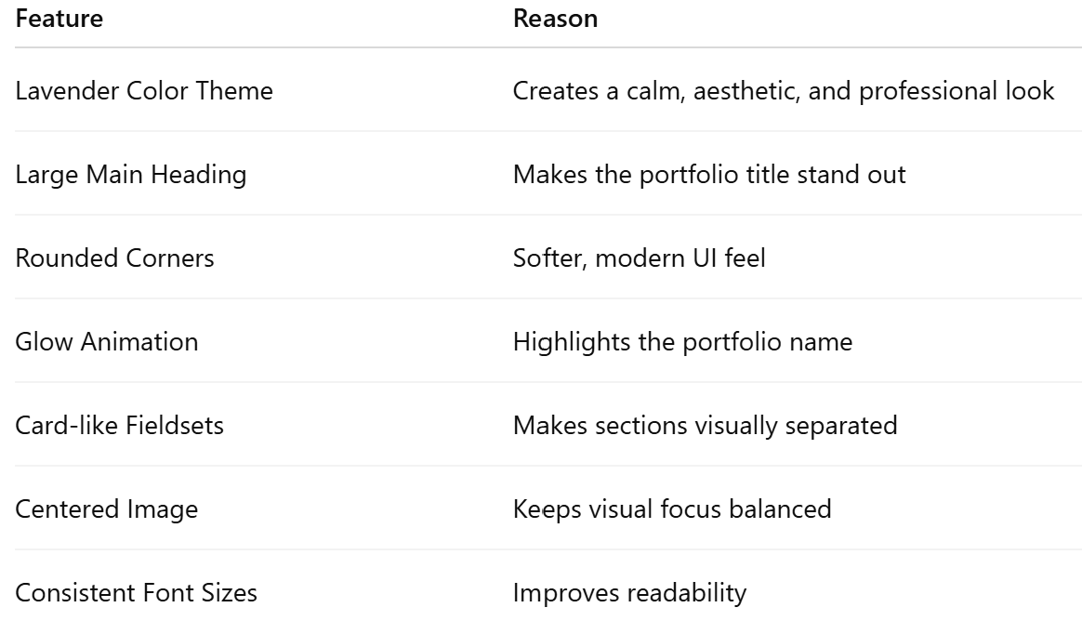

4. Responsiveness Approach
@media (max-width: 768px) { ... }
For mobile screens:
- Header switches to column layout
- Font sizes are reduced
- Navigation links stack neatly
- Image size becomes smaller
- Content aligns vertically
This ensures:
- Mobile friendliness
- Better usability on phones and tablets

5. Button & Form Styling
- Buttons use hover transitions and shadows
- Inputs highlight when focused
- Lavender accent color improves visual consistency
#contact input:focus {
border-color: var(--secondary-color);
box-shadow: 0 0 6px var(--secondary-color);
}

6. Code Structure Summary
Section | Purpose
Reset | Normalizes styling
Root Variables | Theme management
Body | Base typography
Header | Main title & navigation
Main Layout | Image + Content
Forms | Contact form styling
Buttons | Interactive UI
Animations | Visual enhancement
Media Query | Responsive design

7. Conclusion
This CSS demonstrates:
- ✔ Use of modern design techniques
- ✔ Responsive design
- ✔ Clean layout with Flexbox
- ✔ Hover effects and animations
- ✔ Custom fonts and color scheme
- ✔ Maintainable code using CSS variables

